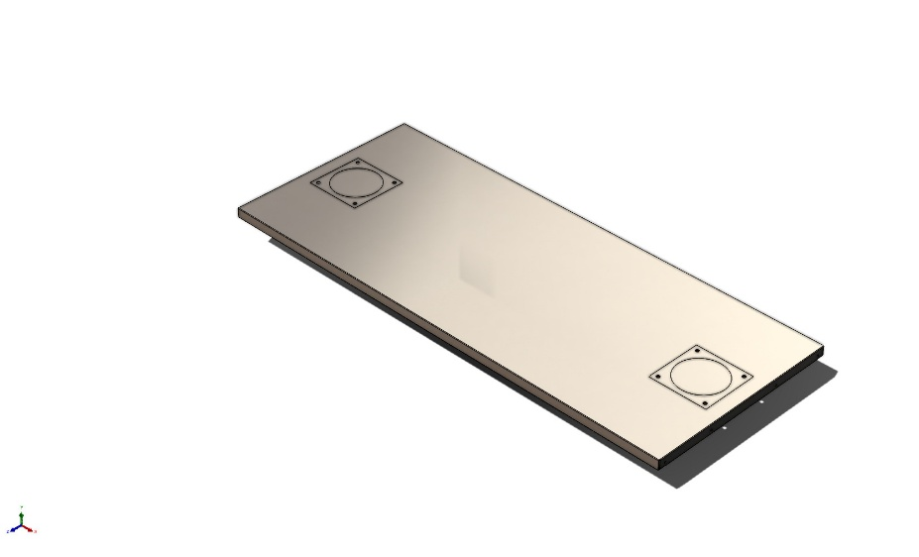 | Simulation of 9054T115_Steel Workbench Top_w_installation_holes  Date: 03 October 2025  Designer: Solidworks  Study name: Static 3  Analysis type: Static  Table of Contents  Description 1  Assumptions 2  Model Information 3  Study Properties 4  Units 4  Material Properties 5  Loads and Fixtures 6  Connector Definitions 7  Interaction Information 7  Mesh information 8  Sensor Details 9  Resultant Forces 10  Beams 10  Study Results 11  Conclusion 14

Description
No Data

Assumptions

Model Information

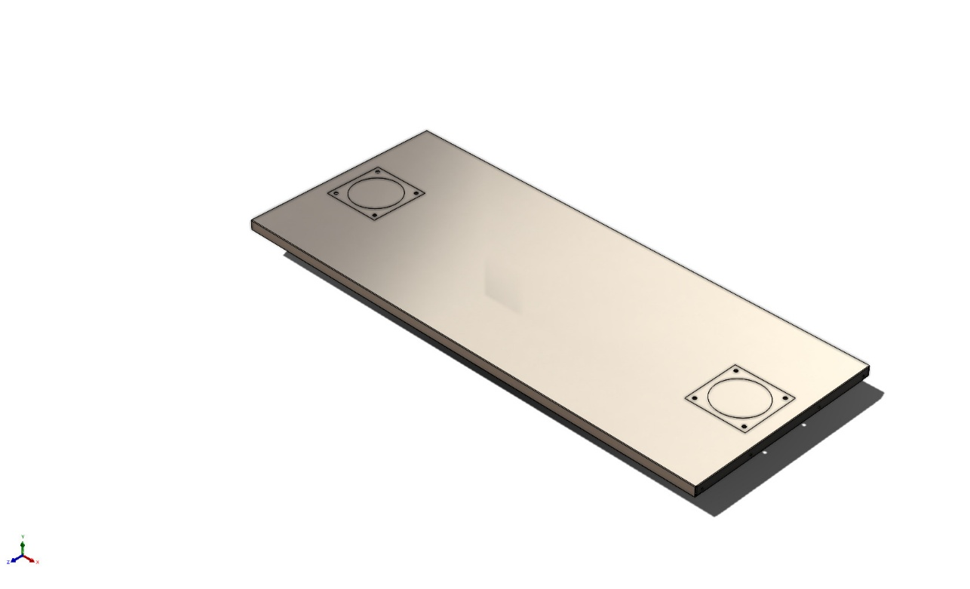
Model name: 9054T115_Steel Workbench Top_w_installation_holes
Current Configuration: 9054T115
Solid Bodies
Document Name and Reference | Treated As | Volumetric Properties | Document Path/Date Modified
LPattern1  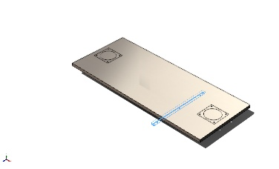 | Solid Body | Mass:0.996488 kg  Volume:0.000124561 m^3  Density:8,000 kg/m^3  Weight:9.76558 N | C:\Users\Lucas\Documents\Projects\Co_Printing\RAAM\Layout\9054T115_Steel Workbench Top_w_installation_holes.SLDPRT  Oct 3 10:49:03 2025
Fillet3  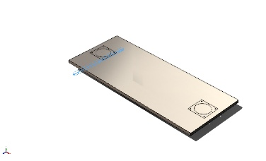 | Solid Body | Mass:0.996488 kg  Volume:0.000124561 m^3  Density:8,000 kg/m^3  Weight:9.76558 N | C:\Users\Lucas\Documents\Projects\Co_Printing\RAAM\Layout\9054T115_Steel Workbench Top_w_installation_holes.SLDPRT  Oct 3 10:49:03 2025
Cut-Extrude8  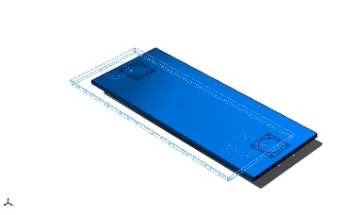 | Solid Body | Mass:35.9309 kg  Volume:0.00449136 m^3  Density:8,000 kg/m^3  Weight:352.122 N | C:\Users\Lucas\Documents\Projects\Co_Printing\RAAM\Layout\9054T115_Steel Workbench Top_w_installation_holes.SLDPRT  Oct 3 10:49:03 2025

Study Properties
Study name | Static 3
Analysis type | Static
Mesh type | Solid Mesh
Thermal Effect: | On
Thermal option | Include temperature loads
Zero strain temperature | 298 Kelvin
Include fluid pressure effects from SOLIDWORKS Flow Simulation | Off
Solver type | Automatic
Inplane Effect: | Off
Soft Spring: | Off
Inertial Relief: | Off
Incompatible bonding options | Automatic
Large displacement | Off
Compute free body forces | On
Friction | Off
Use Adaptive Method: | Off
Result folder | SOLIDWORKS document (C:\Users\Lucas\Documents\Projects\Co_Printing\RAAM\Layout)

Units
Unit system: | SI (MKS)
Length/Displacement | mm
Temperature | Kelvin
Angular velocity | Rad/sec
Pressure/Stress | N/m^2

Material Properties
Model Reference | Properties | Components
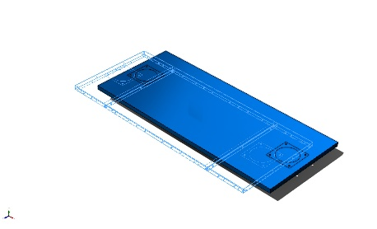 | Name: AISI 316 Stainless Steel Sheet (SS)  Model type: Linear Elastic Isotropic  Default failure criterion: Max von Mises Stress  Yield strength: 1.72369e+08 N/m^2  Tensile strength: 5.8e+08 N/m^2  Elastic modulus: 1.93e+11 N/m^2  Poisson's ratio: 0.27  Mass density: 8,000 kg/m^3  Thermal expansion coefficient: 1.6e-05 /Kelvin | SolidBody 2(LPattern1)(9054T115_Steel Workbench Top_w_installation_holes),  SolidBody 3(Fillet3)(9054T115_Steel Workbench Top_w_installation_holes),  SolidBody 5(Cut-Extrude8)(9054T115_Steel Workbench Top_w_installation_holes)
Curve Data:N/A

Loads and Fixtures
Fixture name | Fixture Image | Fixture Details
Fixed-1 | 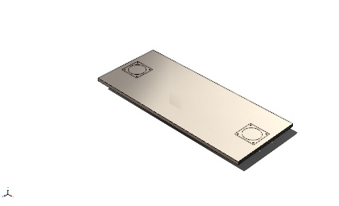 | Entities: 4 face(s)  Type: Fixed Geometry
Resultant Forces
Components | X | Y | Z | Resultant
Reaction force(N) | -0.0703937 | 1,457.99 | -0.000139266 | 1,457.99
Reaction Moment(N.m) | 0 | 0 | 0 | 0

Load name | Load Image | Load Details
Remote Load (Distributed connection)-2 | 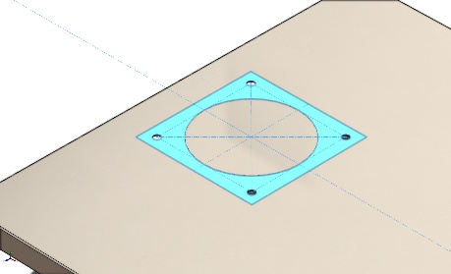 | Entities: 1 face(s)  Connection Type: Distributed  Weighting Factor: Default (Constant)  Coordinate System: Global cartesian coordinates  Translational Components: ---,-543 N,---  Rotational Components: ---,---,---  Reference coordinates: -715 473.15 0 mm
Remote Load (Distributed connection)-1 | 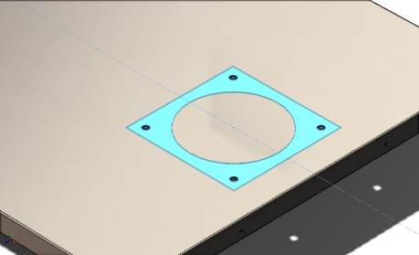 | Entities: 1 face(s)  Connection Type: Distributed  Weighting Factor: Default (Constant)  Coordinate System: Global cartesian coordinates  Translational Components: ---,-543 N,---  Rotational Components: ---,---,---  Reference coordinates: 715 473.15 0 mm
Gravity-1 | 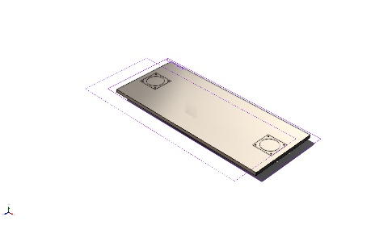 | Reference: Top Plane  Values: 0 0 -9.81  Units: m/s^2

Connector Definitions
No Data

Interaction Information

Interaction | Interaction Image | Interaction Properties
Component Interaction-2 | 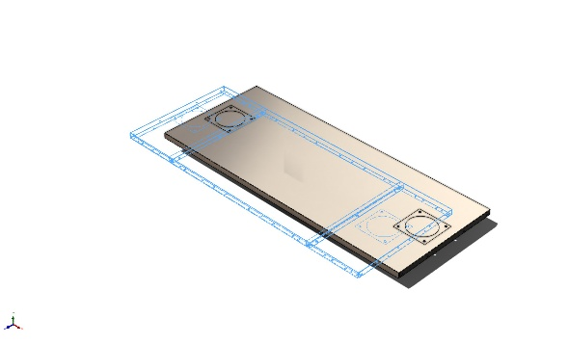 | Type: Bonded  Components: 3 Solid Body (s)  Options: Independent mesh

Mesh information
Mesh type | Solid Mesh
Mesher Used: | Blended curvature-based mesh
Jacobian points for High quality mesh | 16 Points
Maximum element size | 1.50744 in
Minimum element size | 0.075372 in
Mesh Quality | High

Mesh information - Details
Total Nodes | 2203136
Total Elements | 1286920
Maximum Aspect Ratio | 43.764
% of elements with Aspect Ratio < 3 | 90.7
Percentage of elements with Aspect Ratio > 10 | 0.254
Percentage of distorted elements | 0
Time to complete mesh(hh;mm;ss): | 00:01:15
Computer name: | IP-5-FLEX

Mesh Control Information:
Mesh Control Name | Mesh Control Image | Mesh Control Details
Control-1 | 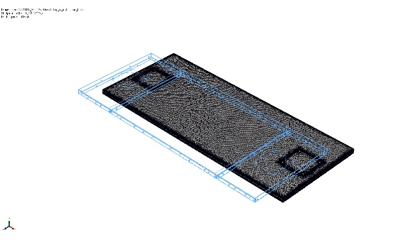 | Entities: 3 Solid Body (s)  Units: mm  Size: 15  Ratio: 15
Control-2 | 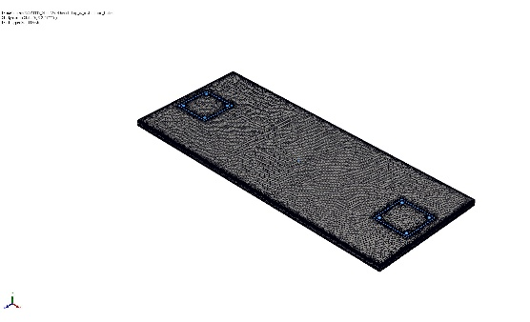 | Entities: 16 edge(s)  Units: mm  Size: 4  Ratio: 4

Mesh Quality Plots
Name | Type | Min | Max
Quality1 | Mesh | - | -
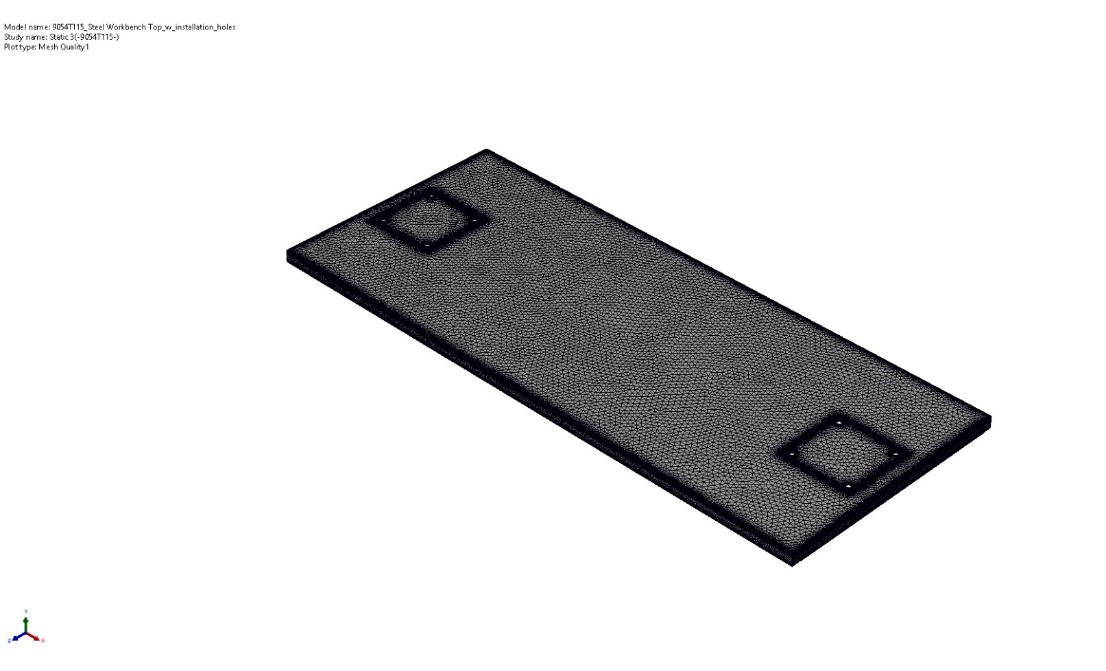
9054T115_Steel Workbench Top_w_installation_holes-Static 3-Quality-Quality1

Sensor Details
No Data

Resultant Forces

Reaction forces
Selection set | Units | Sum X | Sum Y | Sum Z | Resultant
Entire Model | N | -0.0703937 | 1,457.99 | -0.000139266 | 1,457.99

Reaction Moments
Selection set | Units | Sum X | Sum Y | Sum Z | Resultant
Entire Model | N.m | 0 | 0 | 0 | 0

Free body forces
Selection set | Units | Sum X | Sum Y | Sum Z | Resultant
Entire Model | N | -4.7892 | 263.308 | -2.98509 | 263.368

Free body moments
Selection set | Units | Sum X | Sum Y | Sum Z | Resultant
Entire Model | N.m | 0 | 0 | 0 | 1e-33

Beams
No Data

Study Results

Name | Type | Min | Max
Stress1 | VON: von Mises Stress | 2.779e+01N/m^2  Node: 172216 | 1.197e+08N/m^2  Node: 238999
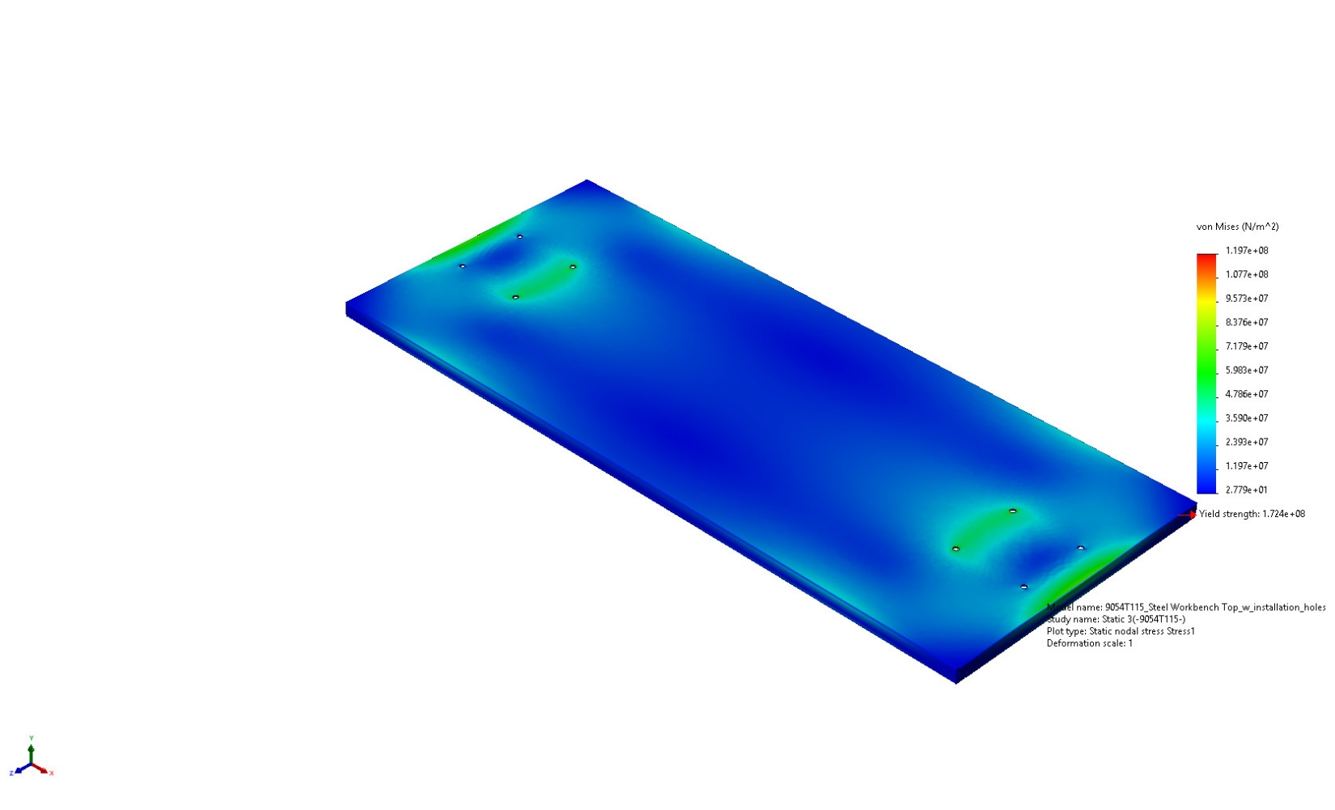
9054T115_Steel Workbench Top_w_installation_holes-Static 3-Stress-Stress1

Name | Type | Min | Max
Displacement1 | URES: Resultant Displacement | 0.000e+00mm  Node: 12851 | 3.463e+00mm  Node: 1988448
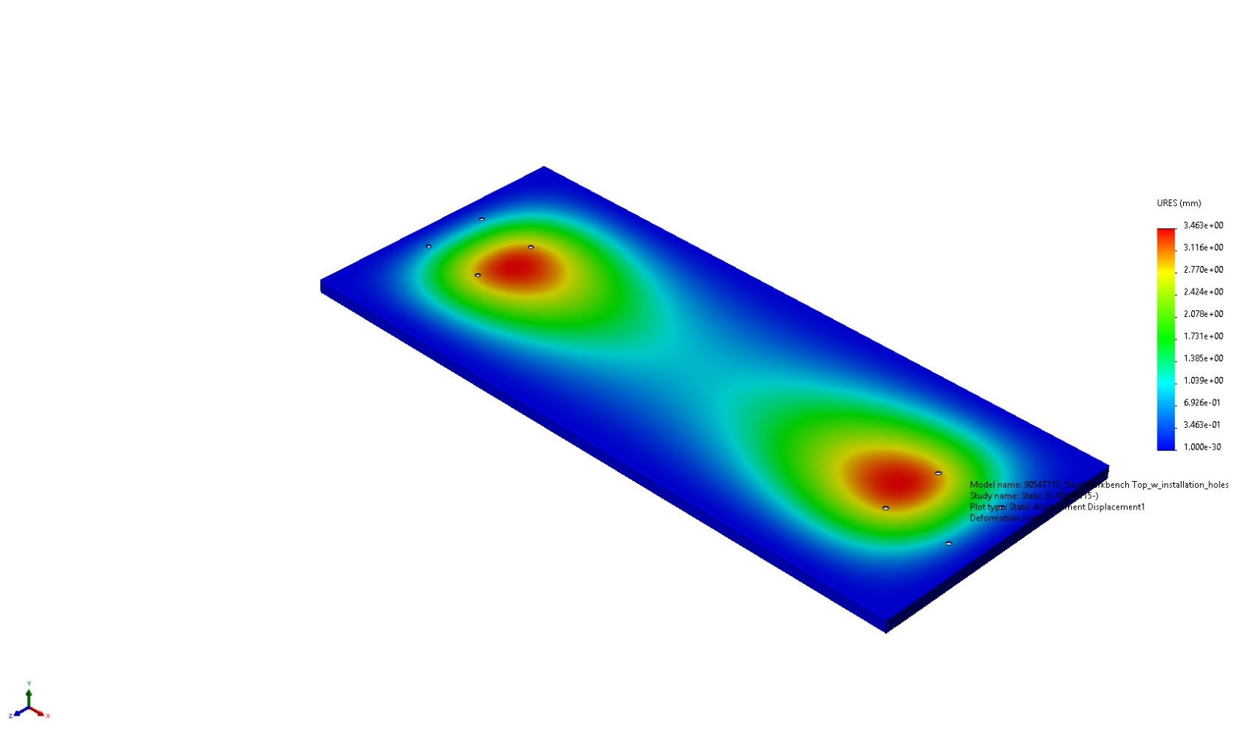
9054T115_Steel Workbench Top_w_installation_holes-Static 3-Displacement-Displacement1

Name | Type | Min | Max
Strain1 | ESTRN: Equivalent Strain | 1.445e-10  Element: 1067586 | 4.158e-04  Element: 1249859
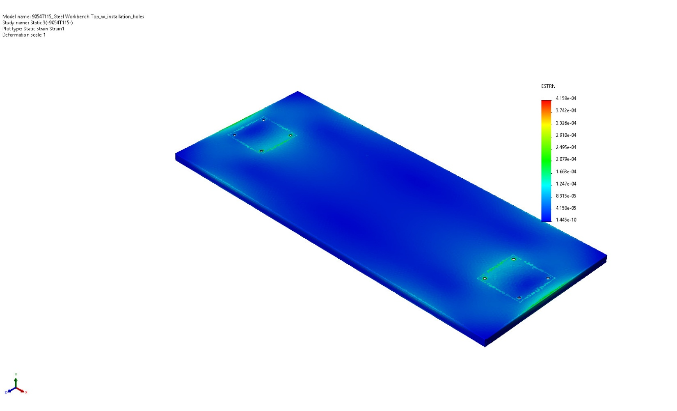
9054T115_Steel Workbench Top_w_installation_holes-Static 3-Strain-Strain1

Name | Type | Min | Max
Factor of Safety1 | Automatic | 1.441e+00  Node: 238999 | 3.000e+00  Node: 1
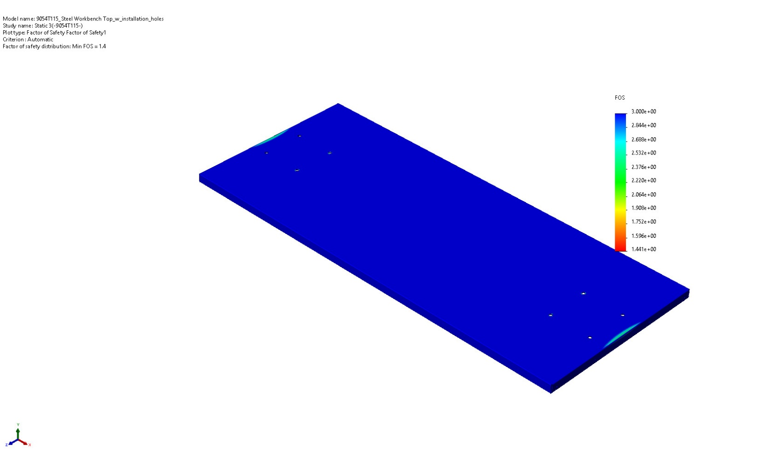
9054T115_Steel Workbench Top_w_installation_holes-Static 3-Factor of Safety-Factor of Safety1

Conclusion

